**Advanced Software Engineering**

**CHILD GUARD SYSTEM**

**Final Specification**

**Instructor:** Dr. Seok-Won Lee **Course:** Advanced software Engineering **Date:** 4 December, 2015

**Team member:**

Sunzu Kim

Jaehwan Lee

Simon Hrabec

Index

**1. Project overview** 5

**1.1 Motivation** 5

**1.2 Background** 5

**1.3 Project Problem Statement** 6

1.3.1 Description 6

1.3.2 Problem 7

1.3.3 Scope and Objectives 8

**1.4 Related Work** 8

**1.5 Supplementary Requirements** 9

1.5.1 Hardware and Application requirement 9

1.5.2 User Interfaces 10

1.5.3 Software Interface 10

1.5.4 Communication Interfaces 10

1.5.5 Non-functional requirements 11

1.5.6 Functional requirements 12

**1.6 Proposed idea / approach** 13

1.6.1 Description 13

1.6.2 Consideration 14

**1.7 Technical solutions** 15

**1.8 Business Plan** 16

1.8.1 Marketing 16

1.8.2 Advertisement 16

1.8.3 Local community 16

**2. Customer Requirements** 17

**2.1 User Requirements** 17

**2.2 System Requirements** 18

**2.3 Domain Requirements** 20

**2.4 Use cases description** 20

**3. Design** 29

**3.1 Analysis Package** 29

**3.2 System Design** 30

3.2.1 Application Specific Layer 30

3.2.2 Interface Layer 30

3.2.3 Sensor Detection 30

3.3 Use case design 31

3.3.1 Use case 1: Login 31

3.3.2 Use case 2: Depart from home, Use case 3: Arrive at home 32

3.3.3 Use case 4: Turn on the Television 33

3.3.4 Use case 5: Turn off the television 34

3.3.5 Use case 6: Turn on the computer 35

3.3.6 Use case 7: Turn off the computer 36

3.3.7 Use case 8: Watch too close the Television 37

3.3.8 Use case 9: Watch the TV maintaining appropriate distance 38

3.3.9 Use case 10: Register cell phone number, Use case 11: Register criteria of using time, Use case 12: Register criteria for the compensation 39

3.3.10 Use case 13: Send a reward message 41

3.3.11 Use case 14: Receive a message 42

3.3.12 Use case 15: Detect the brightness of outside and control the light 43

3.3.13 Use case 16: Record using time 44

3.3.14 Use case 17: Analyze using time 45

**4. Class Diagram** 46

**4.1 Parents’ perspective** 46

**4.2 Child’s perspective** 46

**4.3 The system’s perspective** 47

**5. UI Interface** 47

**5.1 UI Design** 47

5.2.1 Description 49

**6. Testing** 50

**6.1 Testing Strategy** 50

6.1.1 Unit test 50

6.1.1.1 Arduino sensor test 51

6.1.1.2 Tizen test (client) 52

6.1.2 Integrating Testing 53

# **1. Project overview**

## **1.1 Motivation**

At the age of 8 children go to school. At that time parents are being told “Your child has grown a lot already, your suffering is almost over”. As nice as it sounds it is not very precise thing to say. Unlike in the kinder garden children in the elementary school cannot stay long enough for the parent to finish his work and then to pick up the child. That is quite significant trouble for the working parents.

## **1.2 Background**

In 43.5 % of families having an elementary school child both parents are working, making it up to 1.38 million families in total. In some cases they let their child to go to academy after the elementary school. One million elementary school students are left alone to go back home without an adult who can protect them.

|  |
| --- |
|  |

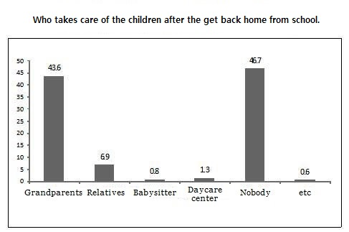

The problem is that not all parents have enough resources to pay for the academy in order to solve the issue. So where should they go? During their way back home are exposed to some threads. After that, they stay home alone for a long time and exposed to TV and computer – using these without any restrictions.

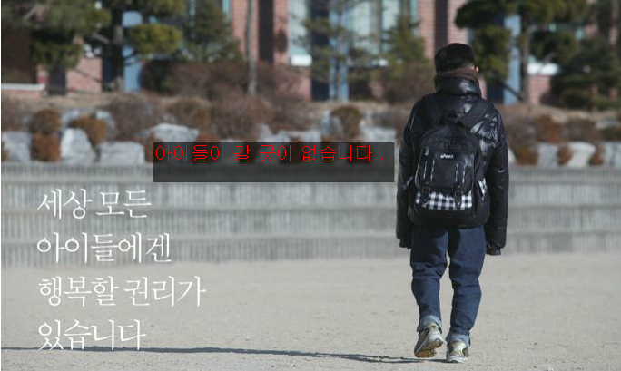

Our idea came up from these concerns.

We suggest a system for the children who are left alone when they finish school supposed to protect them and to check for any dangerous things. In addition, we offer functions to support interaction between child and parent.

## **1.3 Project Problem Statement**

## 1.3.1 Description

Nowadays only few elementary school provide a service to take care of children who are left alone because of lack of teachers. Moreover the service is paid and for parents the price does not seems to be justifiable with respect to the service offered with comparison to academies.

< The biggest worry of working-moms is where to put their children. 50.6% of parents said that they usually put their children to Daycare center. >

## 1.3.2 Problem

The problem is as follows: the "kids stay in Home Alone."

a. To overcome loneliness they watch TV and Computer, but they are exposed for too long.

b. Parents and children don't have enough time to communicate which leads to emotional suffering.

c. When children prepare dinner alone there is a risk of gas leakage and other threats.

d. Because of the absence of parents the children may freely go outside which expose the children to risk of (sexual) violence.

After the year 2012 the 5-day workweek has been established around 90 % of the workers have to leave the work after 6 pm. Because of that 44.9 % of people have a gap between the end of the school and end of the work during which they cannot care about the children - on average the gap time is about 2 hours, for 13.4 % of people it is even 4 hours. According to the survey the result shows that the children have no choice but to stay alone after school.

*(http://www.timesisa.com/news/view.html?section=93&category=96&page=28&no=1992)*

< Child care problem due to the five-day workweek, policy support needed. >

## 1.3.3 Scope and Objectives

The purpose of our system for the children who are left alone when they finish school is to protect them and to check for any dangerous things. By providing these services, also we offer functions to support interaction between child and parent.

Our Child guard system will provide the following functionalities.

* To store all values from the sensor and analyzes all the data.
* To show the values received from the sensor to users.
* To register user’s information.
* To register the criteria of using TV and computer time and reward.
* To send a reward message based on the compensation criteria.

## 

## **1.4 Related Work**

|  |  |
| --- | --- |
| *gaslock.PNG*1)LG U+ IoT - The machine for Gas Lock | - Whenever and wherever the gas valve Status/Remote Control.  - The temperature danger alert.  - Set the timer.  - Remote control home system.  - Strong point: they could use Remote control whenever and wherever. |
| homecctv.PNG2) home CCTV using camera | - Anywhere, check imaging smart-phone/ PC anytime  - Simultaneous viewing of up to four  - Camera, microphone and speaker listening to the sound, capable of delivering  - Looking to hear, talk in real time  - Intrusion detection, Motion Detection instantly alerts sent PUSH  - Video automatically stored 20 seconds after detection  - The time zone setting, and intrusion detection reservation  - In the event of an emergency, alarm / emergency call connection immediately  - Strong point: see using smart-phone.  - Weakness: Too complicated to use. |
| iotswitch.PNG3) IoT Switch using Application and Remote control | - Using Smart-phone or voice, control the light.  - Timer, connect other machine.  - Automatically turns on/off when intrusion happen.  - Strong points: Use remote control and voice. Usability.  - Weaknesses: Not automatic. |
| 4) Send the message Using NFC tag | - When children come to the front door and close to NFC tag and smart-phone  - Automatically sends the message to their parents such as "came home".  - Strong point: easy to use. Using NFC tag.  - Weakness: Security problem (It could be used bad way), Not automatic. |

## **1.5 Supplementary Requirements**

## 1.5.1 Hardware and Application requirement

Hardware of the system is composed of various Arduino sensors that can detect the behavior of the children, the Web application to check the Arduino sensor’s values and database server primary for data processing and storage.

* User Cell Phone Side

|  |  |
| --- | --- |
| Specification | Particulars |
| OS | Tizen |
| APU | Dual core, 1GHz |
| RAM | 2GB |
| ROM | 1GB |
| Communication Modules | Bluetooth, Wi-Fi, Cellular network, USB |
| Input Method | Touch, Keyboard, Stylus pen |

* Arduino Sensor side
* Digital Light Sensor, Distance detect Sensor, Motion Sensor
* Database

|  |  |
| --- | --- |
| Name | MySQL Query |
| Objective | Manage recorded data and query |
| Input Subject | All Servers |
| Unit | SQL query |
| Time/Speed | Immediately |
| Relation with other input | Server’s all input |
| Screen form & composition | None |
| Data form | SQL query |
| Instruction format | SQL query |
| End Message | None |

## 1.5.2 User Interfaces

|  |  |
| --- | --- |
| Name | Sensor detecting and data gathering |
| Objective | Detect and send a message to Web Server |
| Input Subject | Each sensor(motion, light, distance ) |
| Time/Speed | Real time |
| Relation with other input | None |
| Screen form & composition | None |
| Data form | Protocol data |
| Instruction format | Device signal mapping |
| End Message | End signal |

**Table 1 Arduino Sensor User Interface**

|  |  |
| --- | --- |
| Name | Input and check data in Cell Phone(Tizen) |
| Objective | Checking the message has received from various sensors  Registration required appropriate standards |
| Input Subject | Cell Phone |
| Unit | Display, Button |
| Time/Speed | As fast as possible |
| Relation with other input | Arduino Sensor |
| Screen form & composition | Child Guard Application |
| Data form | Protocol data |
| Instruction format | None |
| End Message | End signal |

**Table 3 Cell Phone (Tizen) User Interface**

## 1.5.3 Software Interface

- Language: Java, java applet, java script

## 1.5.4 Communication Interfaces

|  |  |
| --- | --- |
| Name | Communication to Cell Phone with Arduino Sensor |
| Objective | Processing client transmit first-aid journal  Get the sensor value and then transmit to app in Cell phone |
| Input Subject | Cell phone and Arduino |
| Unit | Packet |
| Time/Speed | Real time |
| Data form | Push alarm message |
| Instruction format | Socket handshake |
| End Message | Socket end |

## 1.5.5 Non-functional requirements

* Interface
* The Interface shall contain menus where parents can enter the information.
* Physical
* The systems requires network connection in order to serve its functions
* Design
* The application will be done as a mobile application.
* Implementation
* The system shall use Tizen operating system.
* The system shall use Arduino uno which is based on a C-like programming language
* Organization
* The system shall be designed using Tizen application program.
* Design and modeling of the system shall utilize UML (Unified Modeling Language).
* Security
* The system will not violate any legislation.
* The system will only allow validated, authenticated parents to access not the child.
* Accessibility
* The interface shall be usable and easily accessible by parents who are not familiar with smartphones.
* The interface shall use an adequate font size to be usable by persons with limited visual acuity.
* Accuracy
* The system shall provide child’s exact arrival/departure time information to the parents – with accuracy of seconds.
* Efficiency
* The system shall be possible to use everywhere to check the data.
* Response
* The system responses shall occur within 30 seconds.
* The user’s requirements shall be adjusted immediately.
* Reliability
* The system will allow nobody except the parents to access the data.
* Robustness
* The system should gracefully handle invalid input (e.g. incorrect input number, name, etc.)
* Safety
* The system shall not accidentally lose any data including phone numbers and the recorded child behavior.
* Usability
* The system shall be easy to access the application.
* The system shall revise the information (e.g. changing cell phone number, compensations and the criteria of using time)
* The system shall be activated automatically.

## 1.5.6 Functional requirements

|  |  |  |
| --- | --- | --- |
| No | Features | Description |
| 1 | User login | Login state |
| Parents can quickly and safely login using the system authentication within registered member. |
| 2 | Confirmation child | Confirms child state |
| When child comes home, it sends a message to his/her parents. |
| 3 | Control the brightness of light | Controls the light state |
| Controls the light in the room according to set needs, avoiding direct sunlight to the child. |
| 4 | Checking operation of electronics | Checks the electronics state |
| If child uses the TV or computer, it automatically checks the devices and sends a message. |
| 5 | Automatically turn on/off the TV | Measures the distance |
| When the child comes too close to the TV, the TV automatically turns off. If the child restore the distance, turn the TV turns back on. |
| 6 | Register user information | Input user information state |
| Information about child or parents’ phone number. Input some of compensation. |
| 7 | Monitoring | Monitors the information state |
| Parents confirm the time a child used the computer or TV for a week. |

## **1.6 Proposed idea / approach**

## 1.6.1 Description

During the gap when the child is home alone, we will automatically inform the parents about the activities the child do home alone. In addition, we can control the system remotely. We suggest functions as shown below.

* **Process of a, b, c below sentences**

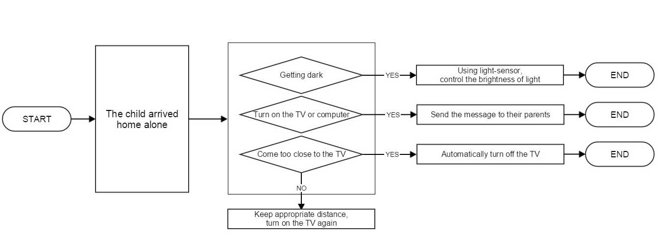

a. When the child comes home and turn on the Television and computer, send the message to their parents such as "came home"," watching TV" or "playing computer". Therefore, the parents can know what the child is doing

b. Control the light in the room according to set needs, avoiding direct sunlight to child, matching the amount of light to his day-cycle.

c. It is not good for their eyesight to watch the TV from close distance. When the child comes too close to the TV, the TV turn off automatically. If the child restore the distance, turn the TV back on.

* **Process of D sentence**

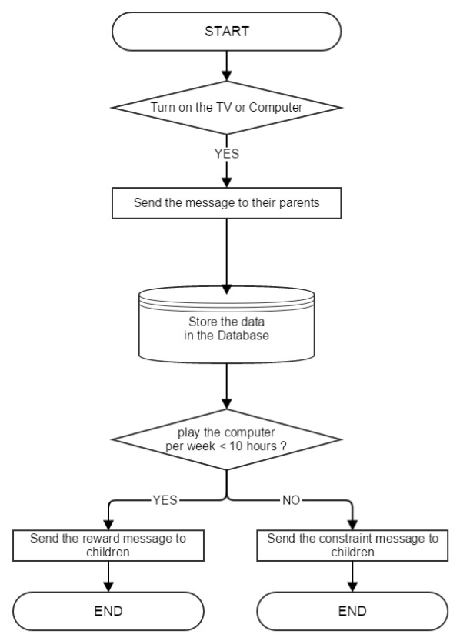

d. When the child watches the television and plays the computer, we automatically collect the data of using hours and save that to the Database table. After analyzing the data, if the child watch the television appropriately, they could get some reward from the parents. For example, if the child play the computer less than 10 hours per week, the message would be sent their parents so that could be induced to give some compensation to the child.

## 1.6.2 Consideration

a. Cost problems of equipment (Various sensors and machine)

b. Survey for checking child’s arrival time and habitat children’s life-cycle such as watching Television time and playing computer game time.

c. Gathering information of available length between the television and children (some children cannot see when they seat too far because of their eyesight.)

d. Continuous maintenance and management

## **1.7 Technical solutions**

1. **Samsung Tizen and Arduino**

First of all, it is important to point out that our project is supported by Samsung. We have borrowed Samsung smartphone Z1 running the Tizen system, Arduino UNO and Wi-Fi router. Tizen is the newly-born operating system which aims to portable and electronic devices. Samsung claims that Tizen is developed to be the leading IoT (Internet of Things) operating system in the close future. By now several different version of Tizen are in use running on variety of devices including Smartphones, personal computers, Smart TVs, washing machines.

1. **Sensor and actuators technologies**

For the purpose of our project we need to use and understand several sensors which arduino will be equipped with.

|  |  |
| --- | --- |
| 거리측정센서.jpg<HC-SR04> | - Ultrasonic ranging module providing a function to measure distance  -non-contact measurement function, the ranging accuracy can reach to 3mm.  -The modules includes ultrasonic transmitters, receiver and control circuit.  - Will be utilized with TV measuring the distance from which the children is watching the TV. |
| 동작감지센서.PNG<PIR RevB > | - The PIR Sensor detects motion by measuring changes in the infrared (heat) levels emitted by surrounding objects. When motion is detected the PIR sensor outputs a high signal on its output pin.  - When the children comes home it can be detected by the sensor and the parents can be notified by a message. |
| light sensor.PNG< Light sensor-BH1750 > | - Digital light sensor  - Sensor is supposed to be used in the room to detect amount of light coming to the room in order to adjust lights in the room. |

## **1.8 Business Plan**

## 1.8.1 Marketing

We target to fully working parents with children in the range of 8-16 years.

The target that we should apply to is the parents who are working and have children (8~16 ages).

a. Making a video which introduces our child guard system, send the advertisement in elementary school's School news alert application (e.g. “School Talk") so the information is send to their parents smartphone.  
 b. Consult with local school board or school representatives in order to put the video on their website to introduce our system.

## 1.8.2 Advertisement

a. In our marketing we aims to advertise our system to home IoT companies, who might collaborate with us.

b. In addition, show the advertisement to childcare centers, their community webpage or messenger chatting room and mother-meeting in cafe whose children belong to elementary or junior school.

## 1.8.3 Local community

We aim to make interaction between parents and children even they are separated. Furthermore, our goal is to help them to keep safe their children in a convenient way. In order to do so, we need a lot of researches to get the information about what parents need, how many hours they have to work and other things. To make the survey efficient, we need some help from school and daycare centers - permission to collect data.

We have to satisfy customer's needs and match their price level expectations. If they feel that our system is too expensive, they would not buy it. We need to focus on this matter to decrease unit cost. So they can get the system for a reasonable price. Besides that, we will focus that they can download the application for free.

# **2. Customer Requirements**

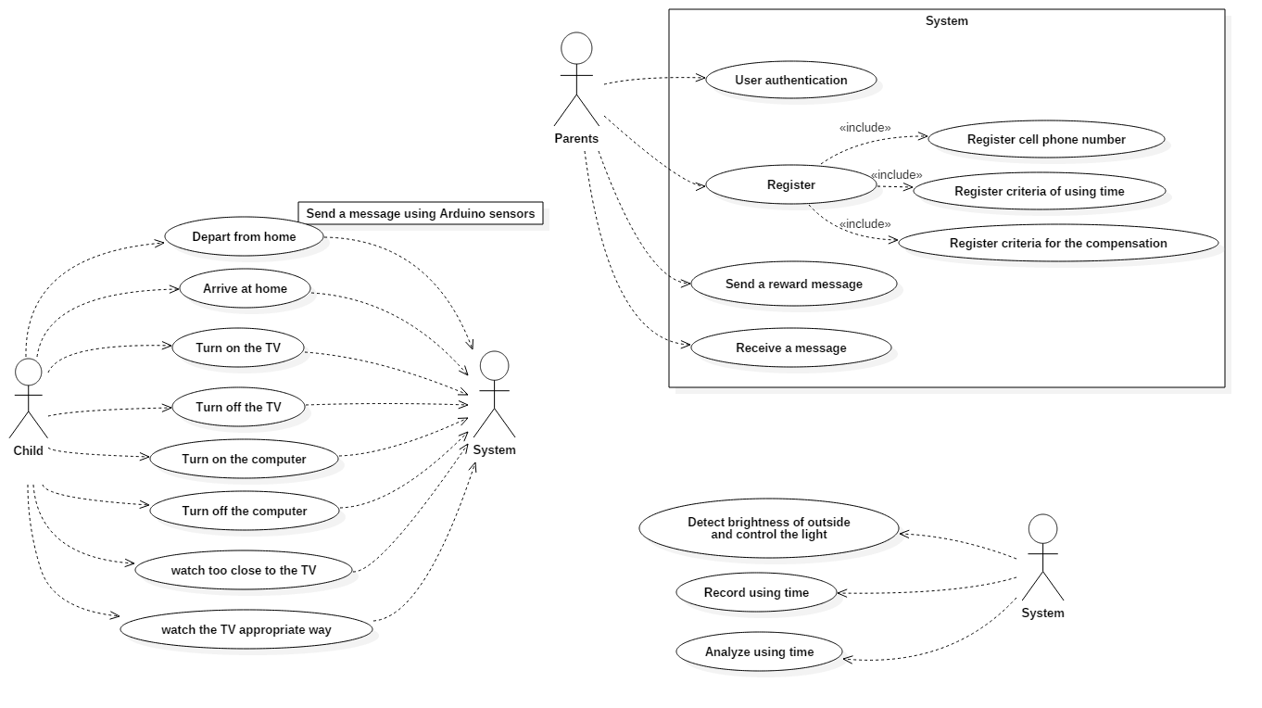

The Actors depicted in the diagram can be one of three types: Parents which represent an actor that can register information into the system, Child which represents an actor that has stayed alone at home safely and System which represents an actor that can automatically control the house and store the data into the system. Parents can register the criteria of using time, compensations, send a message to their children and receive some message from the system.

By selecting to register option in case of parents, parents will be shown menu options of to enter a cell phone number, criteria of using time and criteria the compensations. Registering or removing the information can be possible.

## **2.1 User Requirements**

1. The system shall check whether child arrives at home or not.
2. The system provides the parents with information whether the child came home.
3. The system sends a message to the parents to know their child came home safely.
4. The system shall provide the function to the child to stay safe.
5. The system shall detects the brightness of the living room.
6. The system shall provide the function to the child to control the brightness of light automatically.
7. The system shall provide the function to the child to protect from harmful environment.
8. The system shall check if home has any dangerous threats.
9. The system shall provide the function to the parents to perceive the threats.
10. The system shall automatically provide the function to the parents to get a message.
11. The system provides their parents with information whether the child turns on/off the TV.
12. The system provides their parents with information whether the child turns on/off computer.
13. The system shall provide the function to the parents to check the child’s location in front of television.
14. The system shall provide the function to the child to perceive appropriate distance when the child watch the television.
15. The system shall provide the function to the parents to confirm the hours of use.
16. The system shall provide the function to the parents to register the user information.
17. The system shall store data for the using-time of television or computer in the system.
18. The system shall offer the function to the parents to set criteria for the compensations.
19. The system shall provide the function to the child to get the parents’ rewards.

## **2.2 System Requirements**

1. The system shall provide the function to the parents to login the system.

- The system shall require the parents to enter an ID and password in order to login to the system.

- Once the parents has logged into the system, the parents will be given a list of menus they can access.

2. The system shall provide the function to the parents to confirm the registration menus.

- It provides the menu to register the parents' cell phone numbers.

- It provides the menu to register the child's cell phone number.

- It provides the menu to register the basis for the TV and computer using time.

3. The system shall provide the function to the parents to register at least one more number when the parents register their child's cell phone number.

4. When the parents register the criteria for the proper use of TV and computer time, the system shell provide the function to the parents to be able to register on a weekly basis.

- When the parents set the criteria to two hours per day, not to exceed to register 14 hours a week, the system shall give a notification message and control not to register if the parents input for more than 14 hours.

5. The system shall get the value of the motion sensor with Arduino sensor when the child came into the house.

- It provides a message to the parents including the arrival time.

6. The system shall get the value of the motion sensor with Arduino sensor when the child have gone out of the house.

- It provides a message to the parents including the departure time.

7. When the dark outside, the system shall turn on the living room by using the sensor. A message will be presented to the parents.

8. When the television and computer turned on/off, the system shall send a message to the parents.

9. For watching the television an appropriate distance, the system shall provide the menu to the parents to register the criteria.

- The criteria of appropriate distance is one meter or more, the system shall notify the parents to register more than one meter.

10. While the television is turned on, if the child sits and watches in front of the television less than the set criteria of distance, the system shall turn off the television by automatically. If the child maintains the appropriate distance which the parents set, the system shall turn on the television by automatically.

- When the motion sensor and the distance measuring sensor is recognized, that the values are transmitted to the system.

- Read the appropriate distance value based on the table, its value is less than the criteria value, the system shall turn off the television.

- The distance measuring sensor value is higher than the appropriate distance criteria, the system shall turn on the television again.

- Transmitting the distance measuring sensor value and motion sensor value to be stored in the database in real time through the system (required for comparison).

11. The system shall provide using the television and computer time during the week through the screen.

- The system shall compare the accumulated usage time is less than the registered cumulative usage time for a week.

- The usage time is less than that, compensation button will be activated at the bottom of the screen.

- Click the button, registered compensation will be sent to the child.

## **2.3 Domain Requirements**

1. The system will consists of three parts – Home part, user device part and server part.

2. The part of the system based at the house or apparent will consists of sensors and Arduino Uno microcontroller.

3. The part of the system for user mobile device will be made on Tizen system usable on smartphone device Samsung Z1.

4. The server side will maintain the communication between the house and the user and provide the application logic.

5. One house might be controlled/observed by multiple users over multiple phones.

6. The system will work continuously, any failure at the home side will be notified to the user in no more than one minute.

7. All the activity of the children will be stored on the server including data from the past.

## **2.4 Use cases description**

|  |  |
| --- | --- |
| **Use-Case ID** | 1 |
| **Use-Case Name** | Login |
| **Actors** | Child |
| **Description** | This use case handles parents logging to the system. |
| **Pre-conditions** | The parents has an existing account in the system. |
| **Post-conditions** | The parents is authenticated to the system and is able to use it. |
| **Primary Flow** | 1. The system prompts the parents for ID and password. 2. The parents enter ID and password. 3. The system verifies ID/password in the database. 4. The parents access the main pages. |
| **Alternate Flow** | 1. The system prompts the parents for ID and password. 2. The parents enter ID and password. 3. The system does not find matching ID/password in the database. 4. The parents is denied a logon to the system. |

|  |  |
| --- | --- |
| **Use-Case ID** | 2 |
| **Use-Case Name** | Depart from home |
| **Actors** | Child |
| **Description** | This use case handles parents perceiving the child went outside. |
| **Pre-conditions** | The child has stayed at home. |
| **Post-conditions** | The system perceives the child go outside. |
| **Primary Flow** | 1. The motion sensor detects whether the child go outside. 2. The system checks the departure time. 3. The system sends a message to their parents. 4. The parents get a message about the time and information. |
| **Alternate Flow** |  |

|  |  |
| --- | --- |
| **Use-Case ID** | 3 |
| **Use-Case Name** | Arrive at home |
| **Actors** | Child |
| **Description** | This use case handles parents perceiving the child came home. |
| **Pre-conditions** | The child has finished the school, and come home immediately. |
| **Post-conditions** | The system perceives the child arrive at home. |
| **Primary Flow** | 1. The motion sensor detects whether the child have come home. 2. The system checks the arrival time. 3. The system sends a message to their parents. 4. The parents get a message about the time and information. |
| **Alternate Flow** |  |

|  |  |
| --- | --- |
| **Use-Case ID** | 4 |
| **Use-Case Name** | Turn on the Television |
| **Actors** | Child |
| **Description** | This use case handles parents perceiving the child turned on the television. |
| **Pre-conditions** | The child has successfully come and stayed at home. |
| **Post-conditions** | The child watches the television. |
| **Primary Flow** | 1. The child turns on the television. 2. The system checks what time the television turned on. 3. The system sends a message to their parents. 4. The watching time information is stored the database system to analyze using time. 5. Parents get a message about the starting time. |
| **Alternate Flow** |  |

|  |  |
| --- | --- |
| **Use-Case ID** | 5 |
| **Use-Case Name** | Turn off the Television |
| **Actors** | Child |
| **Description** | This use case handles parents perceiving the child turned off the television. |
| **Pre-conditions** | The child has stayed at home and keep watching the television. |
| **Post-conditions** | The child do not watch the television. |
| **Primary Flow** | * 1. The child turns off the television.   2. The system checks what time the television turned off.   3. The system sends a message to their parents.   4. The watching time information is stored the database system to analyze using time.   5. Parents get a message about how many hours the child watched. |
| **Alternate Flow** |  |

|  |  |
| --- | --- |
| **Use-Case ID** | 6 |
| **Use-Case Name** | Turn on the computer |
| **Actors** | Child |
| **Description** | This use case handles parents perceiving the child turned on the computer. |
| **Pre-conditions** | The child has successfully come and stayed at home. |
| **Post-conditions** | The child plays computer. |
| **Primary Flow** | 1. The child turns on the computer. 2. The system checks what time the computer turned on. 3. The system sends a message to their parents. 4. The playing time information is stored the database system to analyze using time. 5. Parents get a message about the starting time. |
| **Alternate Flow** |  |

|  |  |
| --- | --- |
| **Use-Case ID** | 7 |
| **Use-Case Name** | Turn off the computer |
| **Actors** | Child |
| **Description** | This use case handles parents perceiving the child turned off the computer. |
| **Pre-conditions** | The child has stayed at home and keep playing the computer. |
| **Post-conditions** | The child do not play computer. |
| **Primary Flow** | 1. The child turns off the computer. 2. The system checks what time the computer turned off. 3. The system sends a message to their parents. 4. The playing time information is stored the database system to analyze using time. 5. Parents get a message about how many hours the child played. |
| **Alternate Flow** |  |

|  |  |
| --- | --- |
| **Use-Case ID** | 8 |
| **Use-Case Name** | Watch too close the Television |
| **Actors** | Child |
| **Description** | This use case will not allow the child to watch the television too closely. |
| **Pre-conditions** | Child has stayed at home and successfully turn on the television. |
| **Post-conditions** | The television is automatically turned off by the system. |
| **Primary Flow** | 1. The child turns on the television. 2. The child comes too close to the TV. 3. The distance sensor measures the distance between the child and the TV. 4. The distance data stores the database system to compare with the criteria. 5. The system calculates whether its distance is appropriate or not. 6. The television is automatically shut down by the system. |
| **Alternate Flow** | 8.1.1 The child turns on the television. 8.1.2 Its distance is appropriate 8.1.3 The child keep watching the TV |

|  |  |
| --- | --- |
| **Use-Case ID** | 9 |
| **Use-Case Name** | Watch the TV maintaining appropriate distance |
| **Actors** | Child |
| **Description** | This use case will allow the child to watch the television in appropriate way. |
| **Pre-conditions** | Child has stayed at home and watched the television. |
| **Post-conditions** | Child keeps watching the television. |
| **Primary Flow** | * 1. The child are watching the television.   2. The child comes too close to the TV.   3. The distance sensor measures the distance between the child and the TV.   4. The distance data stores the database system to compare with the criteria.   5. The system calculates whether Its distance is appropriate or not.   6. The television is automatically shut down by the system.   7. The child moves backward and keeps appropriate distance.   8. The television is automatically turned on by the system.   9. The child are watching the television. |
| **Alternate Flow** | 9.1.1 If Its distance is appropriate, the child could keep watching the TV. 9.2.1 The child do not fall back. 9.2.2 The television does not turn on. 9.2.3 The child do not watch the television. |

|  |  |
| --- | --- |
| **Use-Case ID** | 10 |
| **Use-Case Name** | Register cell phone number |
| **Actors** | Parents |
| **Description** | This use case will allow the parents to register parents’ cell-phone number and the child’s number. |
| **Pre-conditions** | The parents has created the numbers. |
| **Post-conditions** | The system has cell-phone books. |
| **Primary Flow** | 1. Parents initiates an input process by selecting “input number” option. 2. The system prompts the parents for inputting cell-phone number. 3. Parents input their cell-phone number. 4. Parents type their children’s cell-phone numbers. 5. The system stores the data to the database system. 6. Parents are redirected to the entering page. |
| **Alternate Flow** | 10.1.1 Parents enter name and cell-phone number.  10.1.2 Parents input incorrect number.  10.1.3 The system shows an error message.  10.1.4 Parents are redirected to the input page. |

|  |  |
| --- | --- |
| **Use-Case ID** | 11 |
| **Use-Case Name** | Register criteria of using time |
| **Actors** | Parents |
| **Description** | This use case will allow the parents to input the criteria of how many time can the child use the devices. |
| **Pre-conditions** | The parents has prepared the criteria of using time. |
| **Post-conditions** | The system store the criteria of using time. |
| **Primary Flow** | 1. Parents initiates an input process by selecting “setting the criteria of using time” option. 2. The system shows a page to the parents to get appropriate using hours. 3. Parents enter the criteria of using hours. 4. The system stores the data to the database system. 5. Parents redirected to the main page. |
| **Alternate Flow** | 11.1.1 Parents initiates an input process by selecting “setting the criteria of using time” option. 11.1.2 The system shows a page to the parents to get appropriate using hours. 11.1.3 Parents enter the criteria of using hours. 11.1.4 Parents input inappropriate hours. 11.1.5 The system shows an error message. 11.1.6 Parents are redirected to the input page. |

|  |  |
| --- | --- |
| **Use-Case ID** | 12 |
| **Use-Case Name** | Register criteria for the compensation |
| **Actors** | Parents |
| **Description** | This use case will allow the parents to make the criteria for the compensation. |
| **Pre-conditions** | The parents has prepared the compensation for their child. |
| **Post-conditions** | The system store the criteria of the compensation. |
| **Primary Flow** | 1. Parents initiates an input process by selecting “setting the criteria of the compensations” option. 2. The system prompts the parents to enter compensations in a form that contains compensation name and specification of rewards. 3. Parents enter the compensations. 4. The system stores the data to the database system. 5. Parents redirected to the “setting the criteria of the compensations” page. |
| **Alternate Flow** | 12.1.1 Parents initiates an input process by selecting “setting the criteria of the compensations” option.  12.1.2 The system prompts the parents to enter compensations in a form that contains compensation name and specification of rewards.  12.1.3 Parents enter the compensations.  12.1.4 Parents type the compensation name too long.  12.1.5 The system shows the error message.  12.1.6 Parents redirected to the “setting the criteria of the compensations” page. |

|  |  |
| --- | --- |
| **Use-Case ID** | 13 |
| **Use-Case Name** | Send a reward message |
| **Actors** | Parents |
| **Description** | This use case handles the parents to send a reward message to their child. |
| **Pre-conditions** | The child have used the TV and computer.  The system have analyze use time of the week.  The child fulfilled the parents’ criteria. |
| **Post-conditions** | The child get a reward message from the parents. |
| **Primary Flow** | 1. Parents initiates a process by selecting “Send a reward message” option. 2. The system prompts the parents to push the button that send a message to their child. 3. The system shows the result of using time of the week. 4. It contains used time of television and computer, parents’ criteria hours and summary of the result. 5. Parents select one of the compensations. 6. The child get a reward message. |
| **Alternate Flow** | 13.1.1 Parents initiates a process by selecting “Send a reward message” option.  13.1.2 The system prompts the parents to push the button that send a message to their child.  13.1.3 The system shows the result of using time of the week.  13.1.4 It contains used time of television and computer, parents’ criteria hours and summary of the result.  13.1.5 The child does not fulfill the parents’ criteria.  13.1.6 Parents do not send a reward message.  13.1.7 Parents redirected to the “Send a reward message” page. |

|  |  |
| --- | --- |
| **Use-Case ID** | 14 |
| **Use-Case Name** | Receive a message |
| **Actors** | Parents |
| **Description** | This use case will allow the parents to get a message about what the child are doing. |
| **Pre-conditions** | The child have come home.  The child have leaved home.  The child turn on/off the TV or computer.  Turn on/off the light of living room by automatically. |
| **Post-conditions** | The parents get messages. |
| **Primary Flow** | 14.1.1 The child comes home alone.  14.1.2 The system perceives the child’s motion.  14.1.3 The system sends a message to their parents.  14.1.4 A message includes arrival time and “arrival message”.  14.1.5 The parents get a message.  14.2.1 The child leaves home alone.  14.2.2 The system perceives the child’s motion.  14.2.3 The system sends a message to their parents.  14.2.4 A message includes departure time and “departure message”.  14.2.5 The parents get a message.  14.3.1 The child turns on/off the TV or computer.  14.3.2 The system send a message to their parents.  14.3.3 A message includes turning on/off time and “turning on/off message”  14.3.5 The parents get a message.  14.4.1 The system turns on/off the light of living room by automatically.  14.4.2 The system sends a message to their parents.  14.4.3 A message includes a “turning on/off message”.  14.4.4 The parents get a message. |

|  |  |
| --- | --- |
| **Use-Case ID** | 15 |
| **Use-Case Name** | Detect the brightness of outside and control the light |
| **Actors** | System |
| **Description** | This use case will perceive the brightness of outside by automatically. |
| **Pre-conditions** | The light has changed and reached a specified criteria |
| **Post-conditions** | Light in the room is adjusted |
| **Primary Flow** | 1. The light has changed 2. Sensor detect the change 3. System evaluate the change to be made 4. The lights are adjusted |
| **Alternate Flow** | 15.1.1 The system detects the brightness of outside  15.1.2 The system turn off the light by automatically  15.1.3 The system send a message to parents and store the values in database. |

|  |  |
| --- | --- |
| **Use-Case ID** | 16 |
| **Use-Case Name** | Record using time |
| **Actors** | System |
| **Description** | This use case will store the data which is how many hours the child use the devices. |
| **Pre-conditions** | The child uses a device. |
| **Post-conditions** | The records are stored. |
| **Primary Flow** | 1. The child starts using the device 2. System remembers such action 3. The child stops using the device 4. The system records a store the using time of the device |
| **Alternate Flow** |  |

|  |  |
| --- | --- |
| **Use-Case ID** | 17 |
| **Use-Case Name** | Analyze using time |
| **Actors** | System |
| **Description** | This use case will compare using time with the criteria. |
| **Pre-conditions** | The child has used the device |
| **Post-conditions** | Evaluation is set |
| **Primary Flow** | 1. The system checks the records 2. The system compares the record with parent settings 3. The systems evaluates whether the criteria has been satisfied. |

# **3. Design**

## **3.1 Analysis Package**

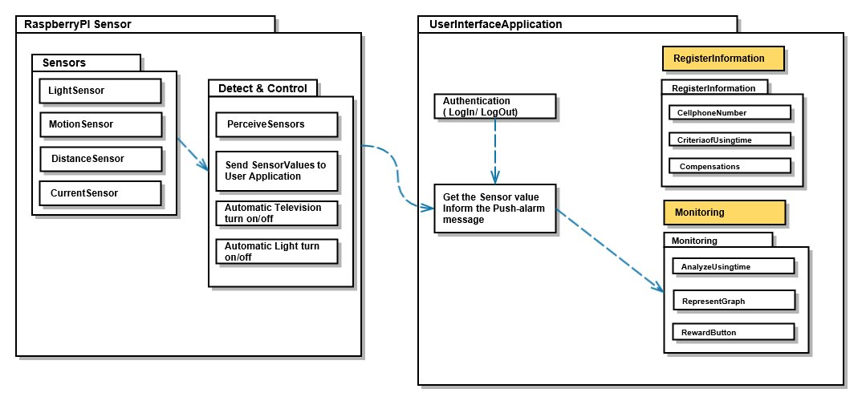

## **3.2 System Design**

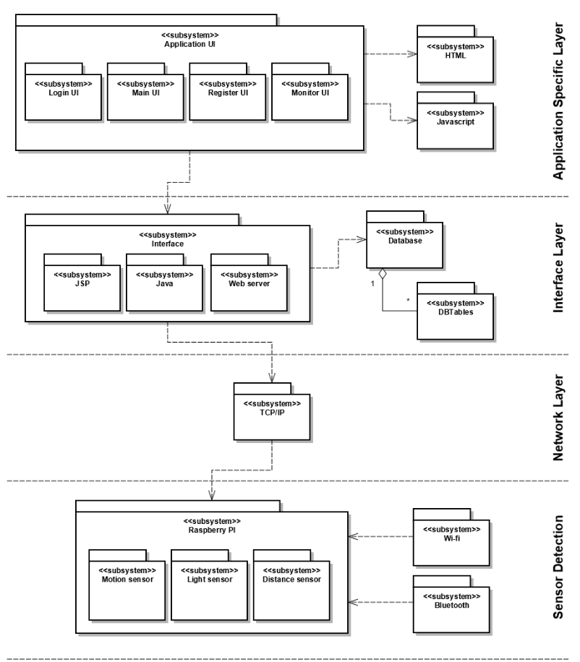

## 3.2.1 Application Specific Layer

This application UI consists the subsystem of loginUI, mainUI, registerUI, monitorUI. The role of this subsystem is to create and manage the user interfaces and screens.

## 3.2.2 Interface Layer

It receives the sensor values collected from the Arduino-uno, stores in the database, and acts screen UI and interface.

## 3.2.3 Sensor Detection

It gathers the sensor values collected from the Arduino-uno

## 3.3 Use case design

|  |
| --- |
| 3.3.1 Use case 1: Login |
| **3.3.1.1 Activity Diagram** |
| **3.3.1.2 Design Sequence Diagram** |
| 3.3.2 Use case 2: Depart from home, Use case 3: Arrive at home |
| **3.3.2.1 Activity Diagram – use case 2** |
| **3.3.2.2 Activity Diagram – use case 3** |
| **3.3.2.3 Design Sequence Diagram** |
| ***3.3.2.3 Design sequence diagram was merged into use case 2,3*** |
| 3.3.3 Use case 4: Turn on the Television |
| **3.3.3.1 Activity Diagram** |
| **3.3.3.2 Design Sequence Diagram** |
| 3.3.4 Use case 5: Turn off the television |
| **3.3.4.1 Activity Diagram** |
| **3.3.4.2 Design Sequence Diagram** |
| 3.3.5 Use case 6: Turn on the computer |
| **3.3.5.1 Activity Diagram** |
| **3.3.5.2 Design Sequence Diagram** |
| 3.3.6 Use case 7: Turn off the computer |
| **3.3.6.1 Activity Diagram** |
| **3.3.6.2 Design Sequence Diagram** |
| 3.3.7 Use case 8: Watch too close the Television |
| **3.3.7.1 Activity Diagram** |
| **3.3.7.2 Design Sequence Diagram** |
| 3.3.8 Use case 9: Watch the TV maintaining appropriate distance |
| **3.3.8.1 Activity Diagram** |
| 3.3.9 Use case 10: Register cell phone number, Use case 11: Register criteria of using time,  Use case 12: Register criteria for the compensation |
| **3.3.9.1 Activity Diagram – Use case 10** |
| **3.3.9.2 Activity Diagram – Use case 11** |
| **3.3.9.3 Activity Diagram – Use case 12** |
| **3.3.9.4 Design Sequence Diagram** |
| ***3.3.9.4 Design sequence diagram was merged into use case 10,11,12*** |
| 3.3.10 Use case 13: Send a reward message |
| **3.3.10.1 Activity Diagram** |
| **3.3.10.2 Design Sequence Diagram** |
| 3.3.11 Use case 14: Receive a message |
| **3.3.11.1 Activity Diagram** |
| 3.3.12 Use case 15: Detect the brightness of outside and control the light |
| **3.3.12.1 Activity Diagram** |
| **3.3.12.2 Design Sequence Diagram** |
| 3.3.13 Use case 16: Record using time |
| **3.3.13.1 Activity Diagram** |
| **3.3.13.2 Design Sequence Diagram** |
| 3.3.14 Use case 17: Analyze using time |
| **3.3.14.1 Activity Diagram** |
| **3.3.14.2 Design Sequence Diagram** |

# **4. Class Diagram**

## **4.1 Parents’ perspective**

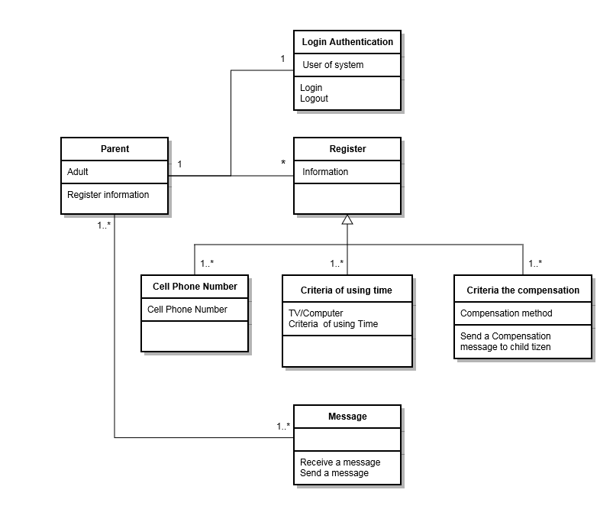

## **4.2 Child’s perspective**

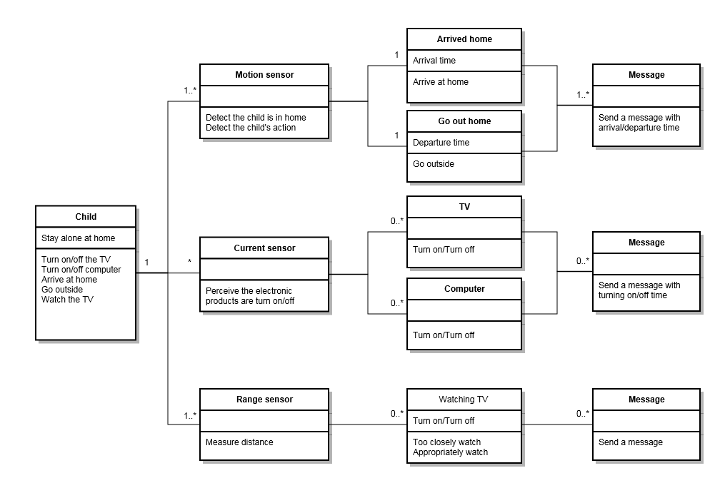

## **4.3 The system’s perspective**

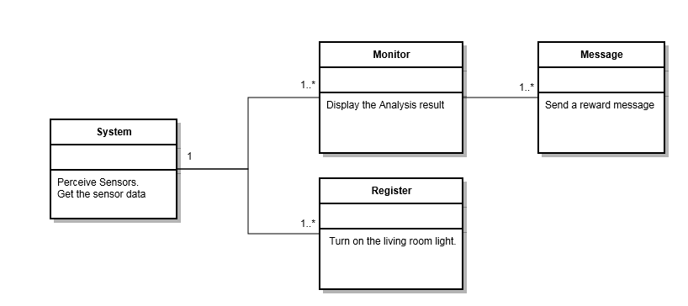

# **5. UI Interface**

## **5.1 UI Design**

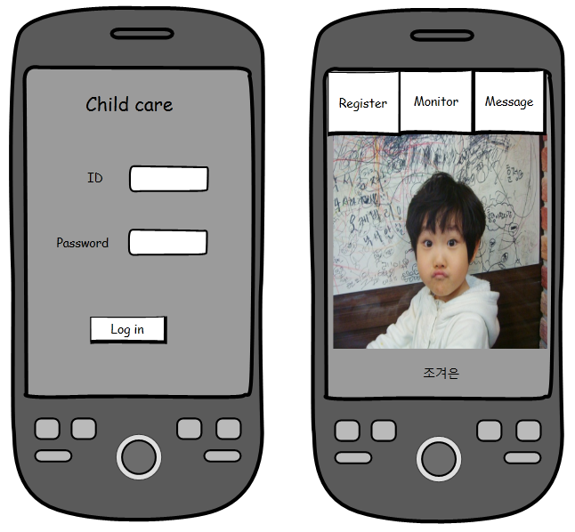

The first screen allow user to log in to his account which is paired to his children. From the second screen it is possible to reach most of the application functionality.

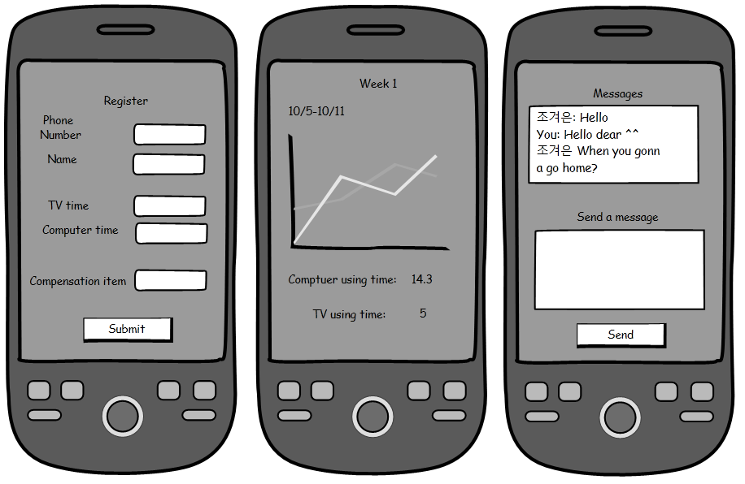

The following screen allow user to register information - his phone number, criteria for watching TV and using computer

The monitoring function shows information on a week basis, including a graph drawing a cumulated time over the week.

Message screen shows messages sent between the parent and the child and allow then to communicate.

**5.2 DB Design**

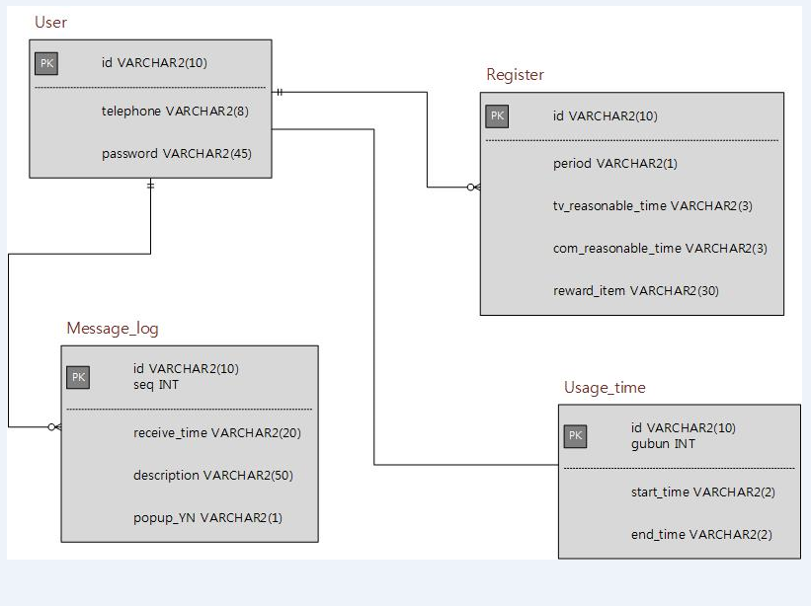

## 5.2.1 Description

1) User Table

The table contains the user's information. Once it is registered a unique user ID, this ID data is primary key.

2) Register

Once registered cell phone number, reasonable time of the television/computer and compensation item, this information is stored.

3) Message log

All the values received by the sensor is stored. The purpose of this is to show in the notification message.

4) Usage Time

Using the television or computer time is stored. The purpose of this is to show in the monitoring screen.

# **6. Testing**

## **6.1 Testing Strategy**

## 6.1.1 Unit test

Our strategy unit test system was conducted divided into two parts.

The two parts are part of the Arduino application Tizen only part of the client, as shown below. Then, proceed to the test for each unit.

|  |  |  |  |  |
| --- | --- | --- | --- | --- |
| **Subsystem** | **Category** | **Work scope** | **Unit test-ID** | **Unit test-Name** |
| **Child-Guard system** | Arduino Uno TEST | Detection sensor and output sensor value | 1 | The child has come to the home alone. |
| 2 | The outside has become dark. |
| 3 | Turn on the television/computer |
| 4 | Too close to watch the television. |
| 5 |
| Tizen TEST | Login | 1 | Registration basic child/parents information |
| Registration Basic information | 2 | Registration reasonable using the television/computer time |
| 3 | Registration compensation items |
| Monitoring | 4 | View the monitoring screen |
| Compensation | 5 | Send the compensation message |

## 6.1.1.1 Arduino sensor test

|  |  |  |  |  |  |  |  |  |  |
| --- | --- | --- | --- | --- | --- | --- | --- | --- | --- |
| **System** | **Work division** | **Unit-test ID** | **Test case name** | **Test condition/Data** | **Expected Results** | **Result** | **Tester** | **Pass** | **Defective information** |
|
| Child-Guard | The child has come to the home alone | 1 | Detect movement through motion sensor and output sensor value | The child had to come to the home | When the child came home, the arrival message is shown with the time through the user-interface. |  |  |  |  |
| The outside has become dark | 2 | Detect brightness through light sensor and output sensor value | The outside is getting dark | Automatically turns on the lights in the living room, and the message is shown through the user-interface. |  |  |  |  |
| Turns on the television/computer | 3 | Detect turning on/off and output sensor value | The television/computer has been turned on/off | The message included 'turned on the television/computer' is shown through the user-interface. |  |  |  |  |
| Too close to watch the television | 4 | Detect distance through distance sensor and output sensor value(too come closely case) | Watch the television too closely | Automatically turns off the television, and the message is shown with 'turned off the television' through the user-interface. |  |  |  |  |
| 5 | Detect distance through distance sensor and output sensor value(keep appropriate distance case) | Go back from the television and keep reasonable distance | The television is turned on automatically, the message is shown through the user-interface. |  |  |  |  |

## 6.1.1.2 Tizen test (client)

|  |  |  |  |  |  |  |  |  |  |
| --- | --- | --- | --- | --- | --- | --- | --- | --- | --- |
| **System** | **Work division** | **Unit-test ID** | **Test case name** | **Test condition/Data** | **Expected Results** | **Result** | **Tester** | **Pass** | **Defective information** |
|
| Child-Guard | Login | 1 | Login status | From the main screen, enter the username(ID) and password | For the pre-registered user, successfully login |  |  |  |  |
| Registration Basic information | 2 | Registration Parent & Children telephone | Enter your cell phone number of parents and children, then click the submit button | When you look up the appropriate screen again, the entered information is shown. |  |  |  |  |
| 3 | Registration appropriate TV & Computer using time | Enter the appropriate time on the TV and the computer, Click on the submit button. | When you look up the appropriate screen again, the entered information is shown. |  |  |  |  |
| 4 | Registration reward item for sending message. | Enter the rewards and click the submit button. | When you look up the appropriate screen again, the entered information is shown. |  |  |  |  |
| Monitoring | 5 | View the monitoring screen | Appropriate television/computer time and usage time of during the week are shown. | When you view the screen again, the television and computer usage time of the week are shown. |  |  |  |  |
| Compensation | 6 | Send the message of compensation item | Click the reward button and confirm that the enrolled rewards are sent. | 1) If the TV / computer usage time is less than the registered appropriate time, the rewards button to Enable. 2) When you click the button, the registered rewards contents are sent to the Tizen-phone of the child. |  |  |  |  |

## 6.1.2 Integrating Testing

Integration testing is to test the following matter how Arduino sensor values are correctly linked to the application of Tizen.

* If the Arduino sensor values is detected, whether Tizen apps in real-time transmission of the message screen.
* Through the monitoring screen of the app, for a week with shows by comparison the TV / computer time and registered with a reasonable time period.
* If you press the button, compensation, rewards information is sent cell phone text as a child.